A.O.K. Laptop System Overhaul

Course Project: IS 436 Structured Systems Analysis and Design

Deliverable 3 – “Process Modeling” (D3)

11/06/2019

Team Name: Meticulous Evolution Consulting

Project Sponsor: Library Services Manager, Paula Langley.

Presented By:

|  |  |  |
| --- | --- | --- |
| **NAME** | **POSITION** | **CONTACT** |
| Upen Adhikari | Quality Assurance | [Adh3@umbc.edu](mailto:Adh3@umbc.edu) |
| Omar Al-Hedari | Project Manager | [Omara2@umbc.edu](mailto:Omara2@umbc.edu) |
| Nima Roomi | Lead Developer/Programmer | [nimar1@umbc.edu](mailto:nimar1@umbc.edu) |
| Alex Varghese | Database Administrator | [varghes1@umbc.edu](mailto:varghes1@umbc.edu) |

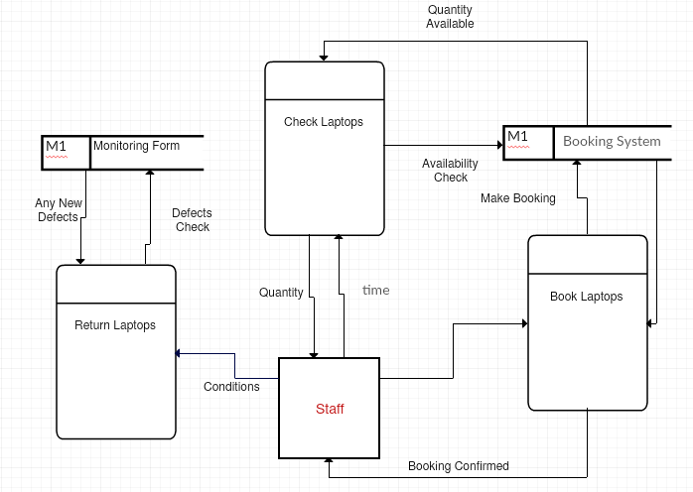

Fig 1.1 Level 0 DFD Diagram

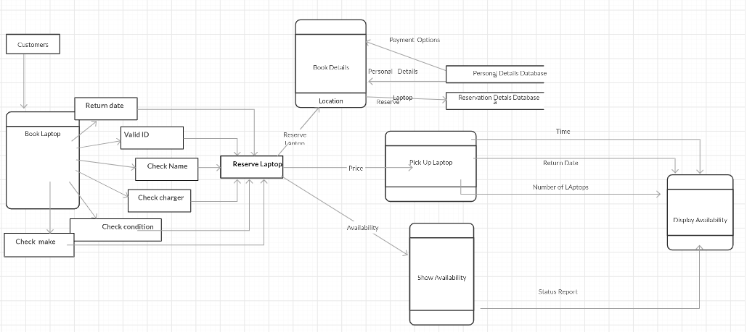

Fig1.2 Level 1 Data Flow Diagram

**PROCESSES**

The data flow diagram shows processes that will occur in the system during the laptop reservation.

1. Book Laptop – This process represents how the customer will log in to the system and perform an online booking of a laptop depicting the time of reservation and return dates
2. Check Laptops – Before picking the laptop at the designated time, the customer must check the laptop and fill a compliance form that shows the defected parts and the parts picked under good condition.
3. Return Laptop – This process will be carried out by the staff and will ic=nclude filling out of a form that will be used to monitor the condition of a laptop when the customer returns it by comparing it with the data collected during picking of the laptop
4. Book Details – This process will be used to save the book details of the customer, including the time the laptop is expected to be picked, the expected return date, and the amount the customer is supposed to pay for the period.
5. Show and display availability – this process will be used to display and save availability data and will contain algorithms that calculate the 15 min, after which a laptop is made available for rebooking.

**Data Stores**

1. **Monitoring form –** This data store keeps data that is used to compare the condition of the laptop before and after the customer returns the laptop
2. **Personal Details –** This data store keeps a record of the data of the customer that includes the name, address and billing information
3. **Reservation Details –** This data store keeps details on the reservation history of every customer and created on the first reservation of the customer.

**Data Flow**

The customer will register and log in to the system. Upon login, they will be required to enter their details, which are confidential and will not be shared. The customer will be assigned a new customer ID, which will be used to track customer interactions throughout the system. The customer will then move to the booking and reservation module, where they will choose a laptop of choice depending on specifications and preference. The customer may reserve a laptop online or in person. If online, there is a 15 min allowance from the specified pick-up time allowed after which the laptop will be available for booking by other customers. On successful reservations, the customer will pick up the laptop, which must be inspected before handing over and the data sent to the monitoring data store with the laptops ID as the identifier.

The customer will then have to return the laptop on the specified date. The system will then bill the customer as per the time spent with the device and collect it from the billing information in the personal details.The laptop is re-inspected as compared to the previously collected data and compared. If the laptop is in good condition and the staff satisfied the customer is cleared to have returned the device

**Kanban Board**

